|  |  |
| --- | --- |
| Student ID | IT22641410 |
| Batch | Y2.S2.WD.04.1 |
| Marks |  |
| 1. Code Quality & Organization   (2 Marks) |  |
| 1. Functionality (3 Marks) |  |
| 1. Creativity & User Interface Design (2 Marks) |  |
| 1. Advanced Features & Data Persistence (3 Marks) |  |
| Total: 10 Marks |  |
| Evaluator |  |

**Description:**

The ToDo app is a comprehensive task manager designed to help users efficiently organize their daily tasks. It allows users to add, update, set, and delete tasks, providing flexibility in task management. The app integrates features for assigning deadlines and specific times to each task, making it easier for users to plan and prioritize their day.

Additionally, the app offers a built-in stopwatch to help users track time spent on tasks, enhancing productivity. The calendar feature provides an overview of upcoming tasks and deadlines, giving users a visual representation of their schedules. This combination of features ensures that users can manage their time effectively, stay on top of their to-dos, and maintain a more organized lifestyle. Whether for personal or professional use, the app is a valuable tool for boosting productivity and achieving goals.

**Screenshots:**



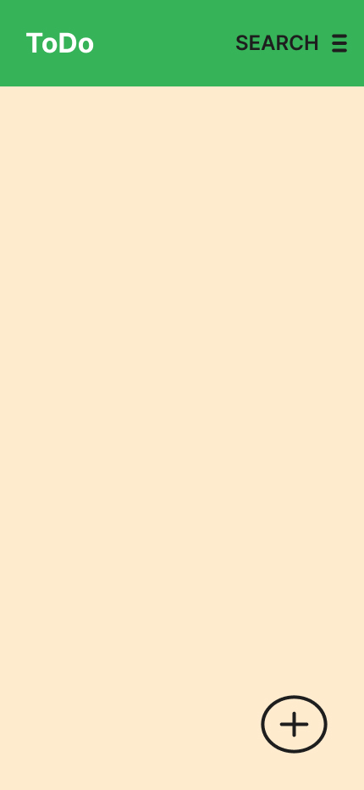 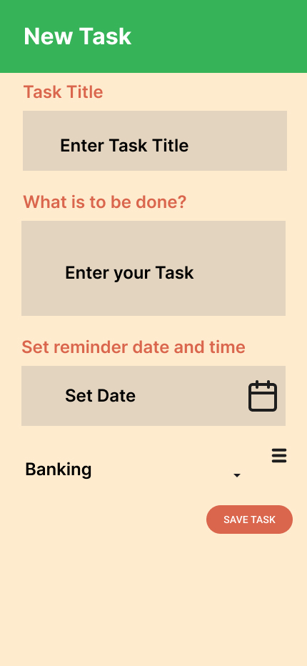

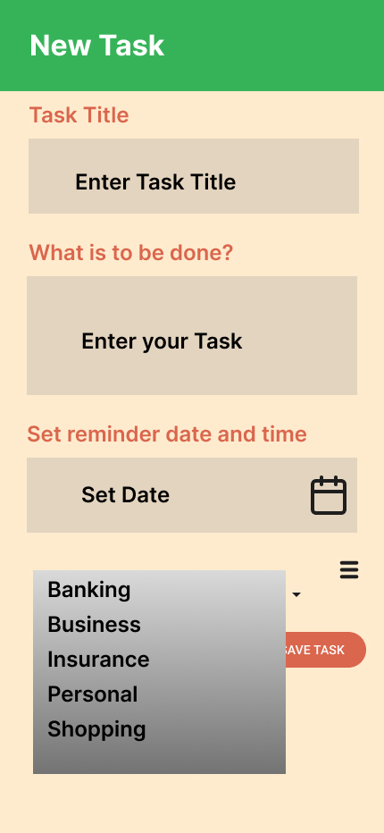 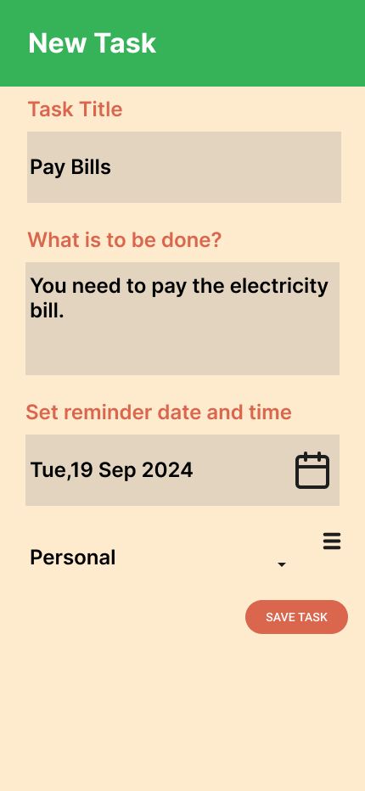

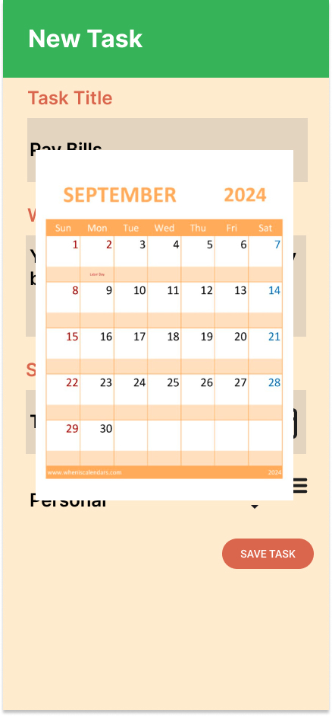 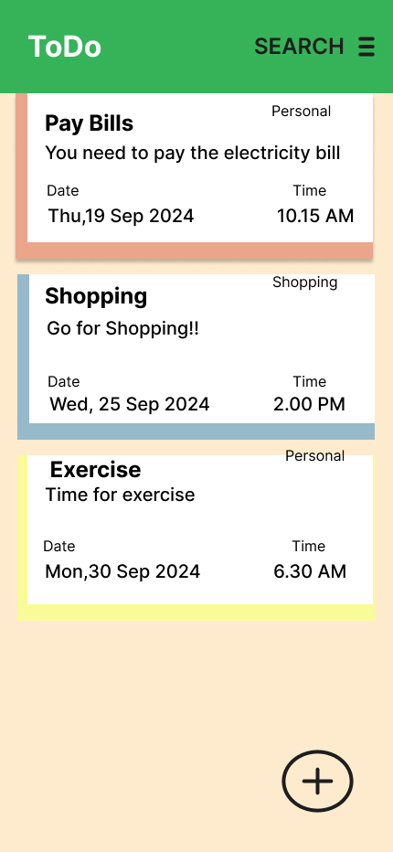

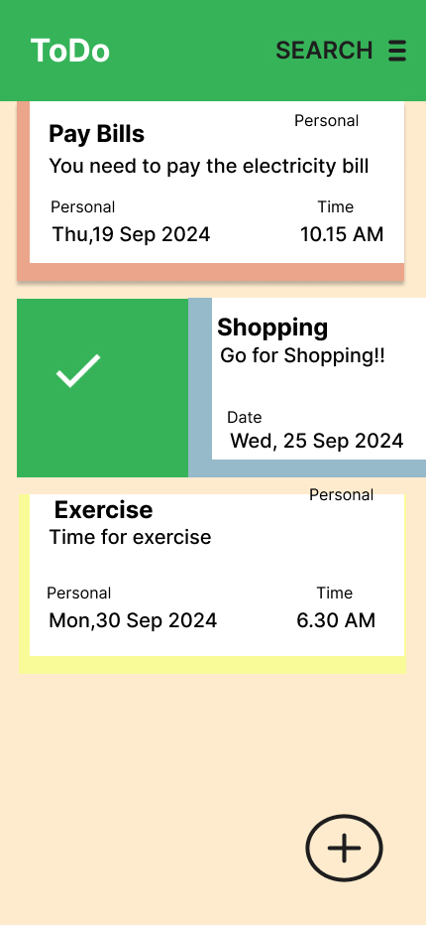 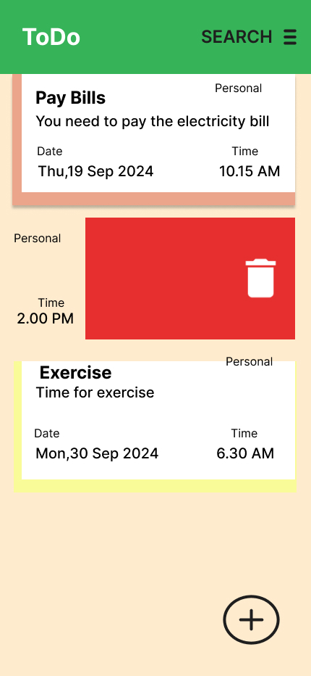

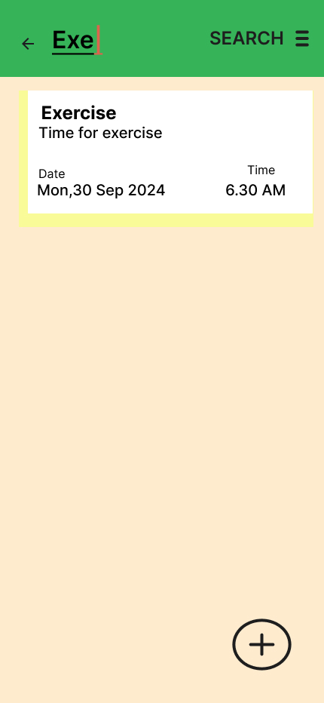 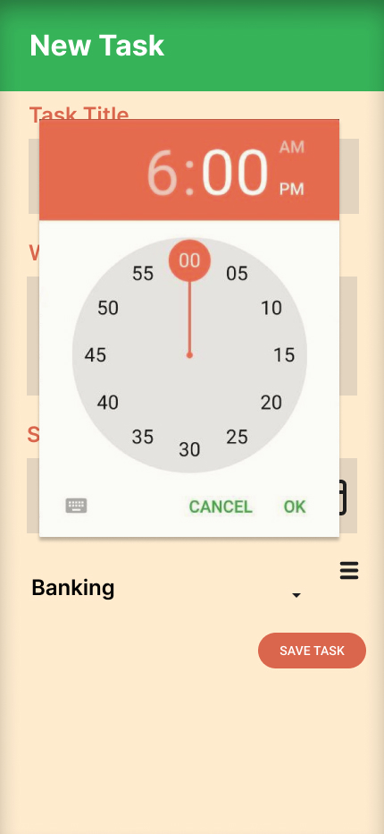

**Content of xml files of Strings and Colors:**

**Strings**

<resources>

<s<resources>

<string name="app_name">ToDo</string>

<string name="toolbar_title">ToDo</string>

<string name="action_search">Search</string>

<string name="new_task_title">New Task</string>

<string name="task_title_label">Task Title</string>

<string name="enter_task_title_hint">Enter Task Title</string>

<string name="task_description_label">What is to be done?</string>

<string name="enter_task_hint">Enter your Task</string>

<string name="set_reminder_label">Set reminder date and time</string>

<string name="set_date_button">Set Date</string>

<string name="save_task_button">Save Task</string>

<string name="category_label">Category</string>

<string name="category_banking">Banking</string>

<string name="category_business">Business</string>

<string name="category_insurance">Insurance</string>

<string name="category_personal">Personal</string>

<string name="category_shopping">Shopping</string>

<string name="search">SEARCH</string>

<string name="personal">Personal</string>

<string name="shopping">Shopping</string>

<string name="banking">Banking</string>

<string name="pay_bills_title">Pay Bills</string>

<string name="pay_bills_description">You need to pay the electricity bill</string>

<string name="shopping_title">Shopping</string>

<string name="shopping_description">Go for Shopping!!</string>

<string name="exercise_title">Exercise</string>

<string name="exercise_description">Time for exercise</string>

<string name="date">Date</string>

<string name="time">Time</string>

<string name="pay_bills_date">Thu, 19 Sep 2024</string>

<string name="pay_bills_time">10.15 AM</string>

<string name="shopping_date">Wed, 25 Sep 2024</string>

<string name="shopping_time">2.00 PM</string>

<string name="exercise_date">Mon, 30 Sep 2024</string>

<string name="exercise_time">6.30 AM</string>

<string name="new_task">New Task</string>

<string name="task_title">Task Title</string>

<string name="when">When?</string>

<string name="save_task">SAVE TASK</string>

<string name="time_picker_ok">OK</string>

<string name="time_picker_cancel">CANCEL</string>

<string name="app_name_exercise">Exe</string>

<string name="app_name_todo">ToDo</string>

<string name="label_date">Date</string>

<string name="label_time">Time</string>

<string name="task_exercise_title">Exercise</string>

<string name="task_exercise_description">Time for exercise</string>

<string name="task_pay_bills_title">Pay Bills</string>

<string name="task_pay_bills_description">You need to pay the electricity bill</string>

<string name="action_search">SEARCH</string>

<string name="action_add">Add Task</string>

<string name="task_type_personal">Personal</string>

<string name="exercise_date">Mon,30 Sep 2024</string>

<string name="exercise_time">6.30 AM</string>

<string name="pay_bills_date">Thu,19 Sep 2024</string>

<string name="pay_bills_time">10.15 AM</string>

<string name="task_time">2.00 PM</string>

<string name="delete_task">Delete</string>

</resources>

**Colors**

<resources>

<color name="colorPrimary">#4CAF50</color>

<color name="colorPrimaryDark">#388E3C</color>

<color name="colorAccent">#ff7058</color>

<color name="litherGray">#a1a1a1</color>

<color name="green">#388E3C</color>

<color name="red">#D32F2F</color>

<array name="random_color">

<item name="red_400" type="color">#e84e40</item>

<item name="pink_400" type="color">#ec407a</item>

<item name="purple_400" type="color">#ab47bc</item>

<item name="deep_purple_400" type="color">#7e57c2</item>

<item name="indigo_400" type="color">#5c6bc0</item>

<item name="blue_400" type="color">#738ffe</item>

<item name="light_blue_400" type="color">#29b6f6</item>

<item name="cyan_400" type="color">#26c6da</item>

<item name="teal_400" type="color">#26a69a</item>

<item name="green_400" type="color">#2baf2b</item>

<item name="light_green_400" type="color">#9ccc65</item>

<item name="lime_400" type="color">#d4e157</item>

<item name="yellow_400" type="color">#ffee58</item>

<item name="orange_400" type="color">#ffa726</item>

<item name="deep_orange_400" type="color">#ff7043</item>

<item name="brown_400" type="color">#8d6e63</item>

<item name="grey_400" type="color">#bdbdbd</item>

<item name="blue_grey_400" type="color">#78909c</item>

</array>

</resources>